Mitnick attack Lab:

To setup the lab, we install rsh:

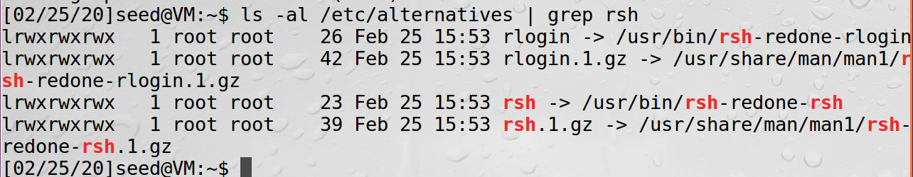

Do the following configuration on X-terminal machine B:



Then try to connect from trust server machine A:



We can also connect with rsh without typing the password:

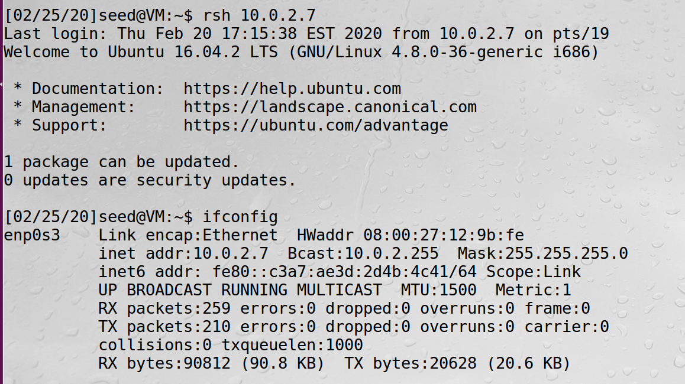

Task 1: Simulated SYN flooding

Ping from X-terminal then make sure it’s in the arp cache, then disconnect:

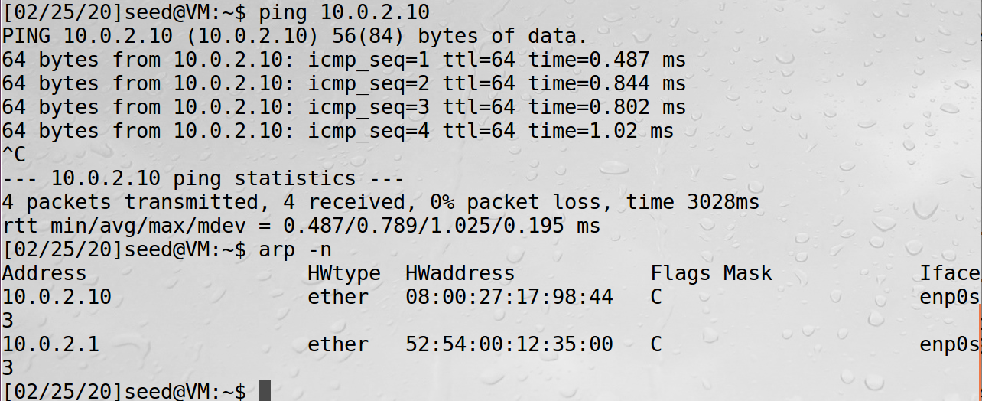

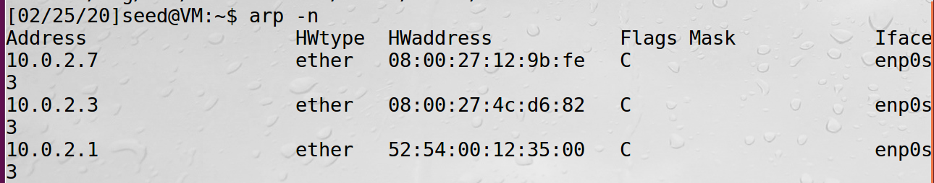

**Task2:**

**Step1:**

To impersonate the trusted server as machine A, we spoof the SYN packet on machine M, first step we seed the SYN packet with some random sequence number:

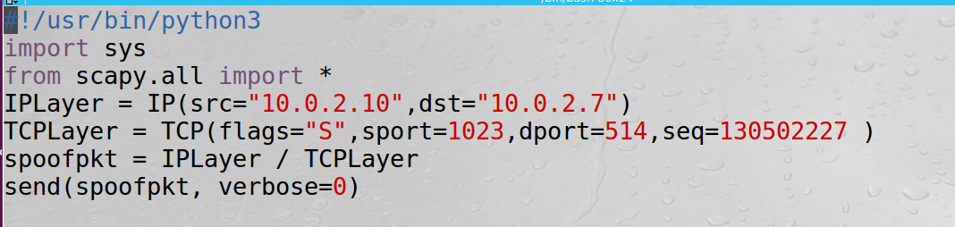

Then we see the wireshark, we should be able to see the

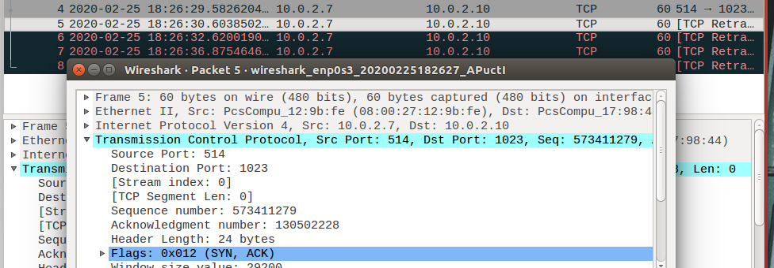

**Step 2: Respond to the SYN+ACK packet.**

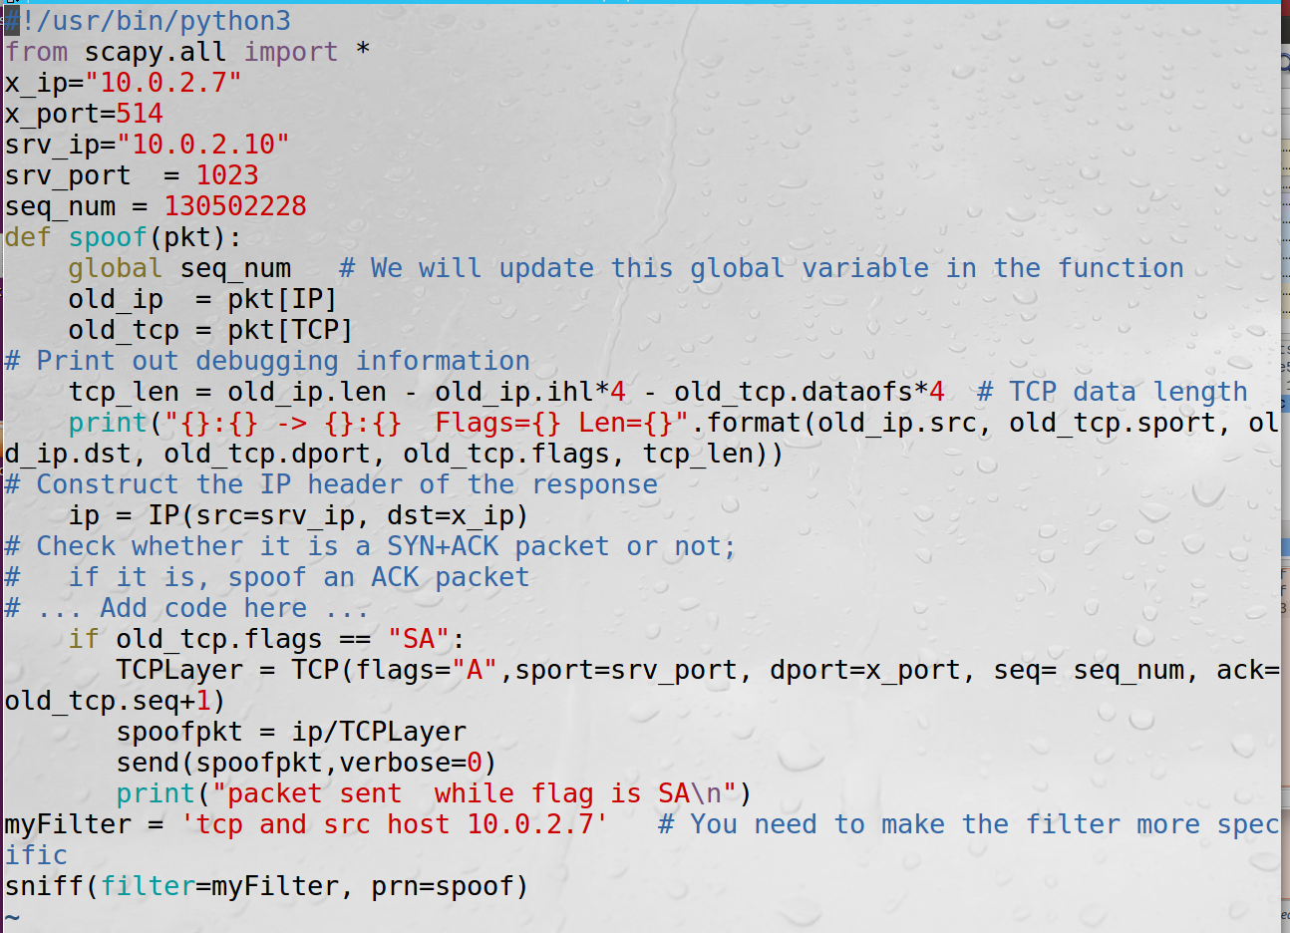

We launch this sniff and spoof program first, then launch step1 code to send the SYN packet to trigger this to execute in order to send the ack packet:



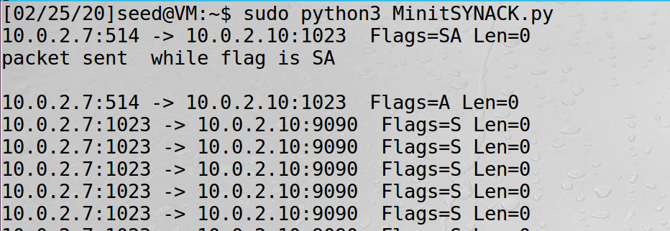

Then we check the wireshark to see the result:



We could see that this “first connection” has been established and the syn after syn+ack has been acked.

**Step3: Spoof the rsh data packet.**

To spoof the data packet, we add the data part below the IP and TCP header.

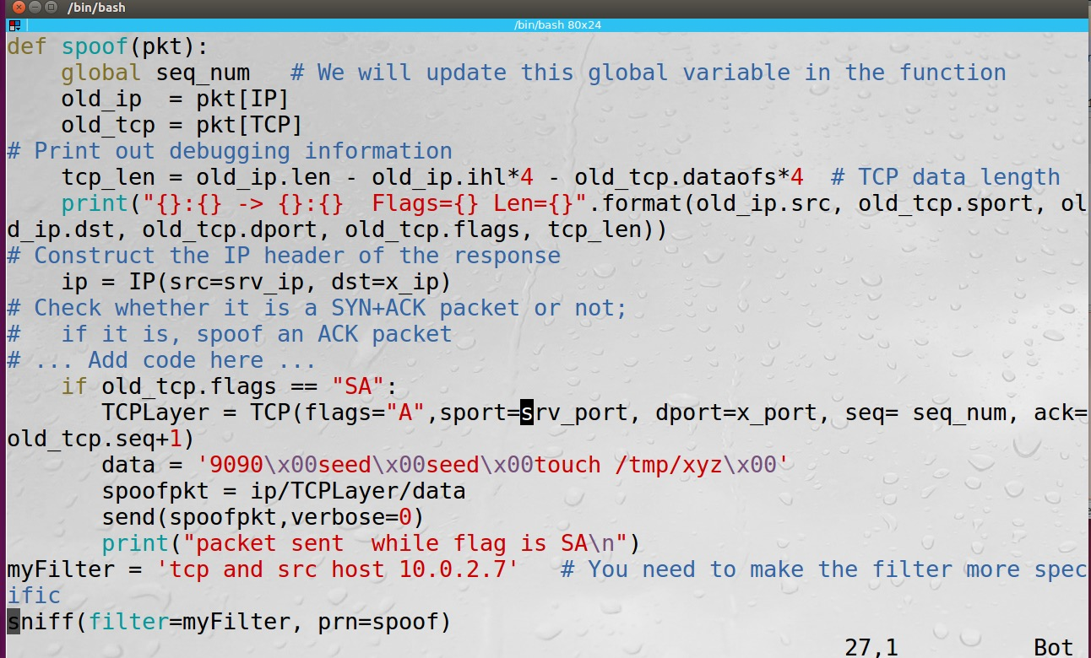

Then we do the same process, then check the wireshark:

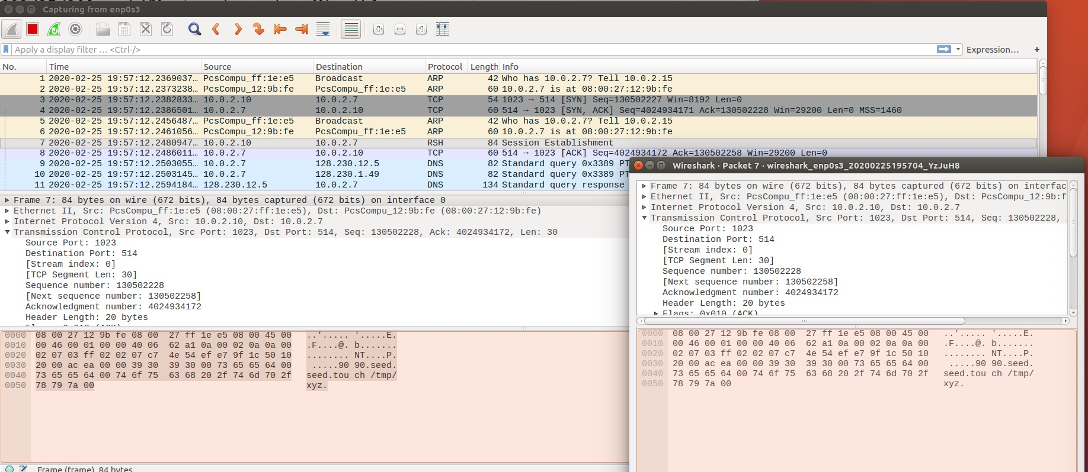

Finding the data in the packet:

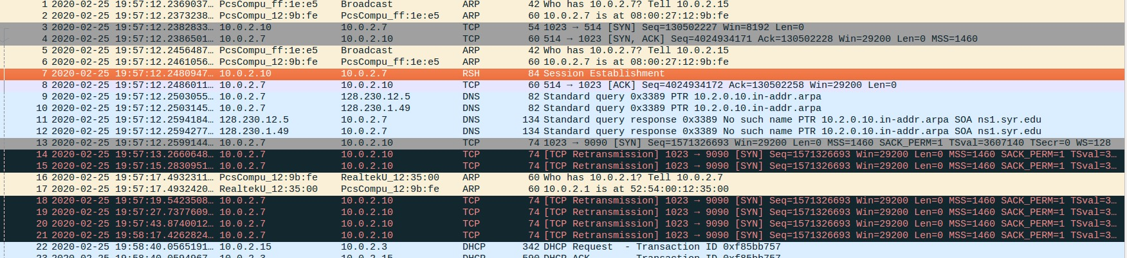

In the following we find that x-terminal keeps sending the syn back to the trusted server, however it’s been disconnected, so that we could see tons of retransmission from port 1023 to 9090, there is no response to syn+ack this syn flag request, it keeps looking for the syn+ack.

And there will be no xyz under /xyz:

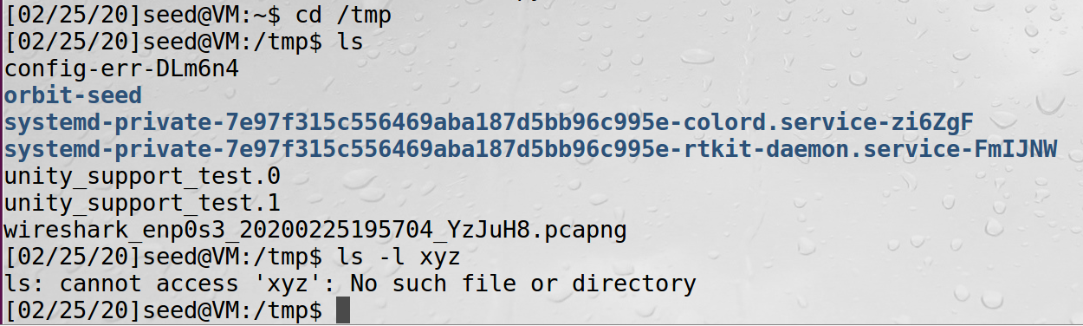

**Task 2.2: Spoof the Second TCP Connection**

**After observing the ack of the first connection, we write the second connection where sets Syn+acks when we meet the syn from port 1023:**

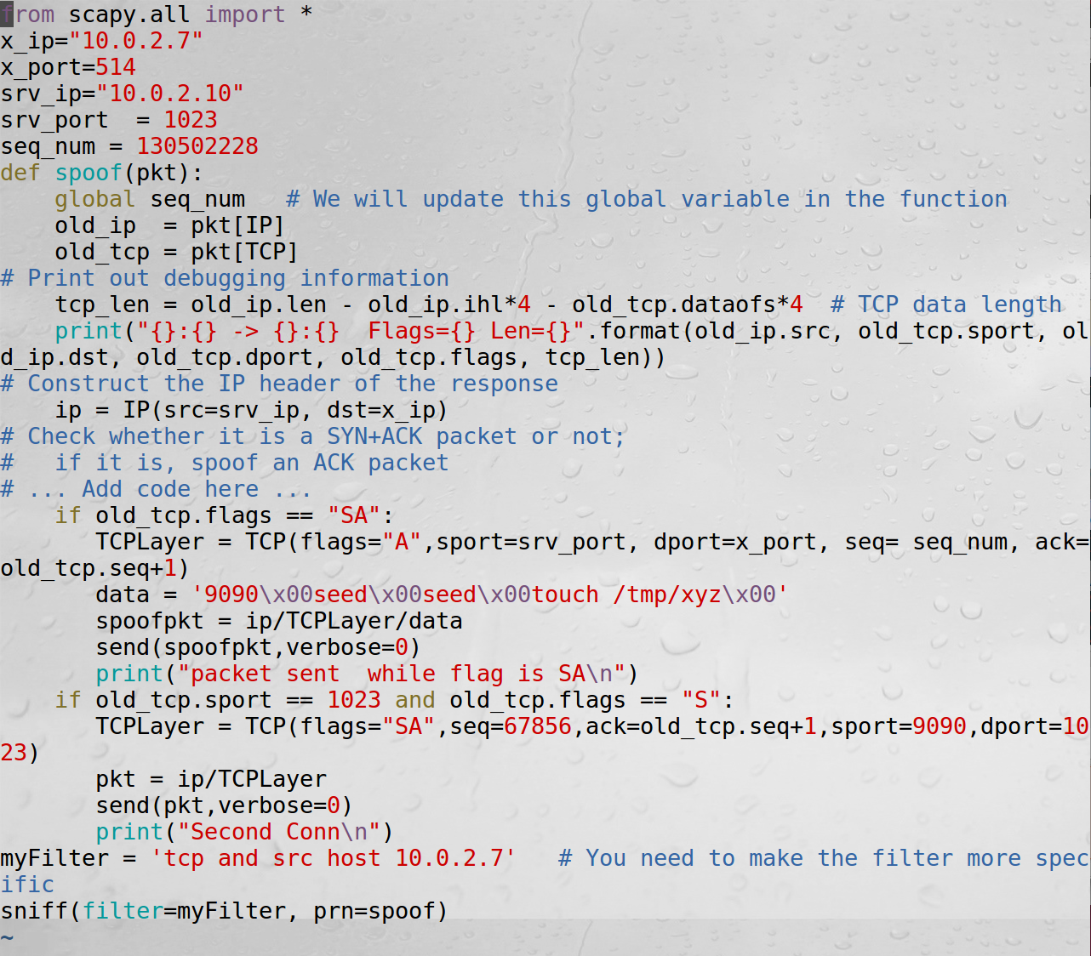

**Observing this, we could find that there are two rounds of threeway handshake:**

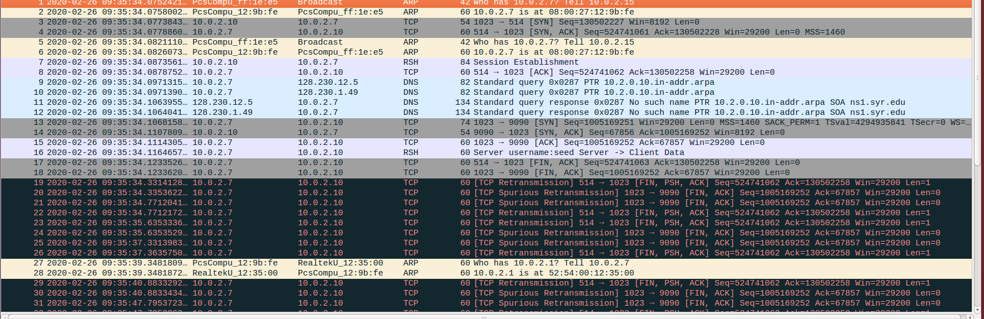

**After that is bunch of Retransmissions from X-terminal to the trusted server:**

**Then let’s check whether this xyz been touched at /tmp, the timestamp corresponds to the time stamp on wireshark:**

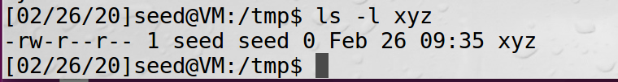

Check the sniff and spoof program, two if branches have all been executed:

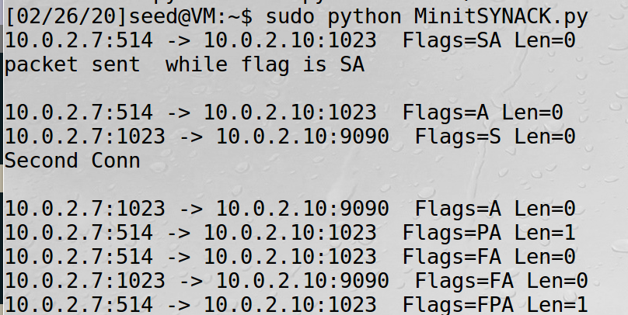

Task 3: Set a Backdoor

To set a backdoor, we need to change the data part in order to write in the .rhosts. As the instructions telling, echo + + > .rhosts would allow all credentials login in without password. So we modify the data part:

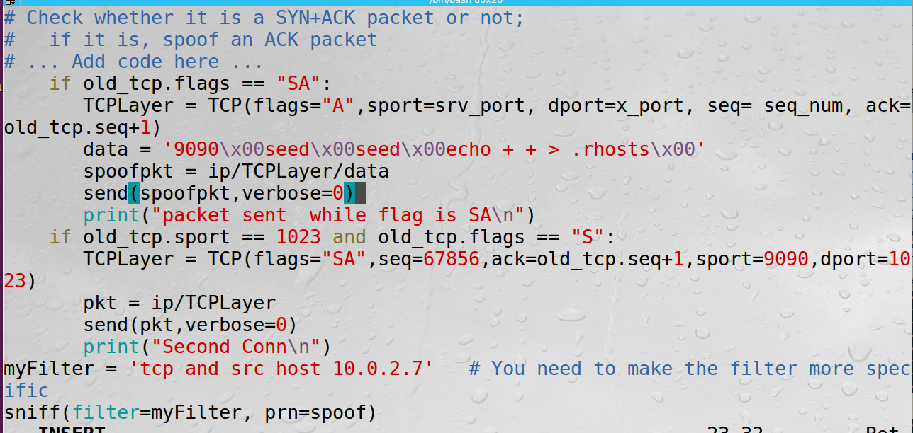

Do the same process, launch the sniff and spoof program, then send the syn to trigger:

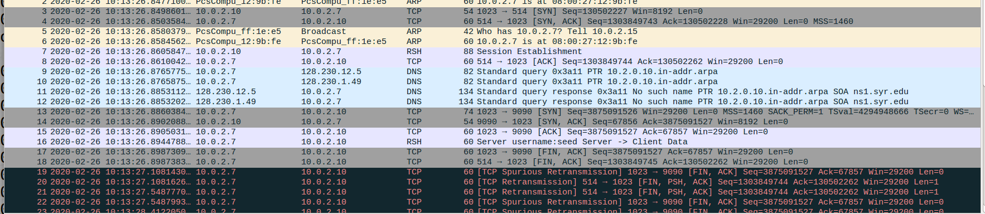

From wireshark, we find the two rounds of handshake have been completed and the rsh conn was established executing the command line echo ++ > .rhosts

If it’s successful, we should be able to login from this middle machine without password:

